You are given two **non-empty** linked lists representing two non-negative integers. The digits are stored in **reverse order**, and each of their nodes contains a single digit. Add the two numbers and return the sum as a linked list.

You may assume the two numbers do not contain any leading zero, except the number 0 itself.

**Example 1:**

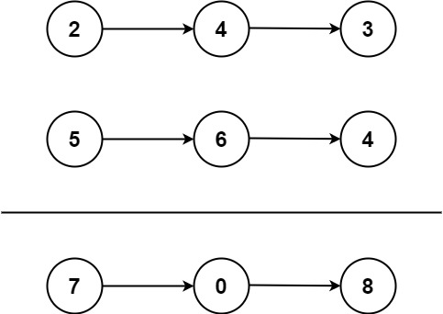

**Input:** l1 = [2,4,3], l2 = [5,6,4]

**Output:** [7,0,8]

**Explanation:** 342 + 465 = 807.

**Example 2:**

**Input:** l1 = [0], l2 = [0]

**Output:** [0]

**Example 3:**

**Input:** l1 = [9,9,9,9,9,9,9], l2 = [9,9,9,9]

**Output:** [8,9,9,9,0,0,0,1]

**Link For Solution**

**https://redquark.org/leetcode/0002-add-two-numbers/**